**APPENDIX F-2. Using HEC-HMS to finish up the model**

Once the model is prepared from ArcGIS using the HEC-GeoHMS, we need to make some changes to the HEC-HMS model prepared

**1). For SCS Loss Method:**

1. **Salt Lake Traid (GHCN) for Oct2010-Sep2011 with base flow**

In this simulation, basic simulation concept is same as of Green and Ampt loss method for KF_C, Iutah site except some input parameter for sub-basin, precipitation and USGS observed data are different as follow.

1. Sub-basin

* SCS curve method is selected as Loss method

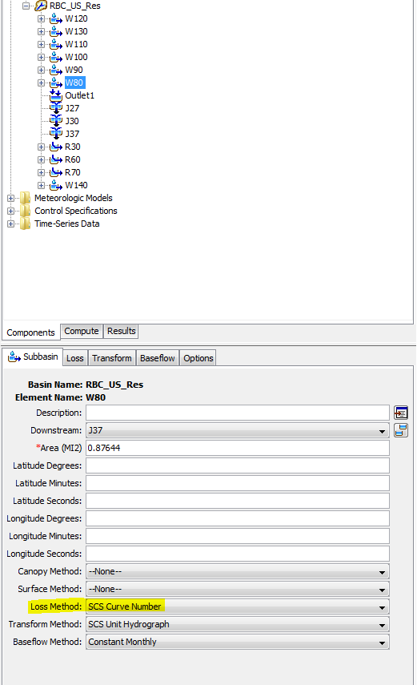

* Under the loss title, corresponding initial abstraction, curve number and impervious percentage values have been entered for each sub basins.

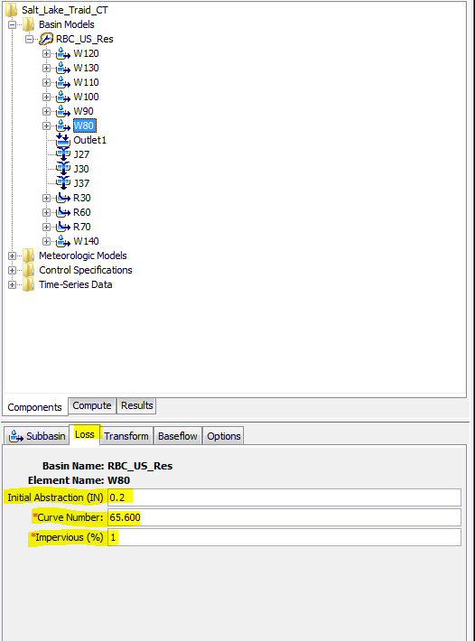

* Lag time (min) under the title “Transform” which are same as of KF_C, Iutah site for each sub basin have been entered.

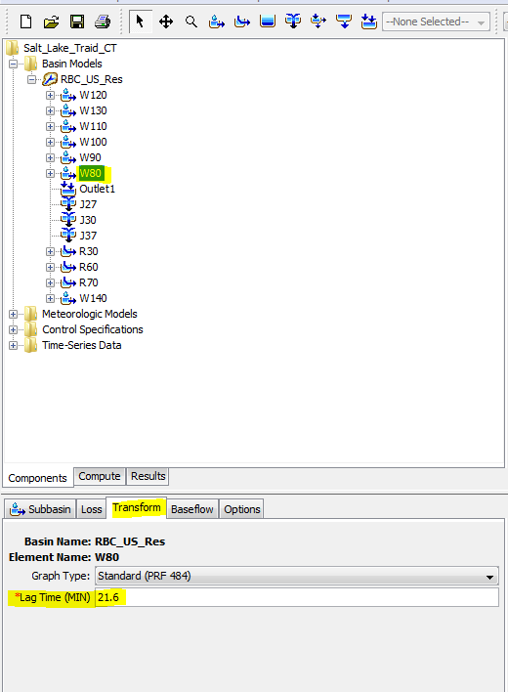

* Corresponding calculated base flow according to USGS, Fort Douglas (10172200) for Oct 2010 - Sep 2011 for each sub- basin have been entered.

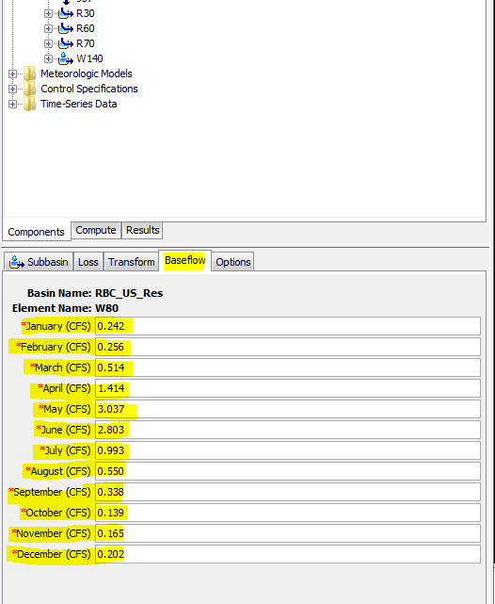

1. Precipitation data

* Under the time-window title, precipitation data from Oct 2010 to Sep 2011 has been entered.

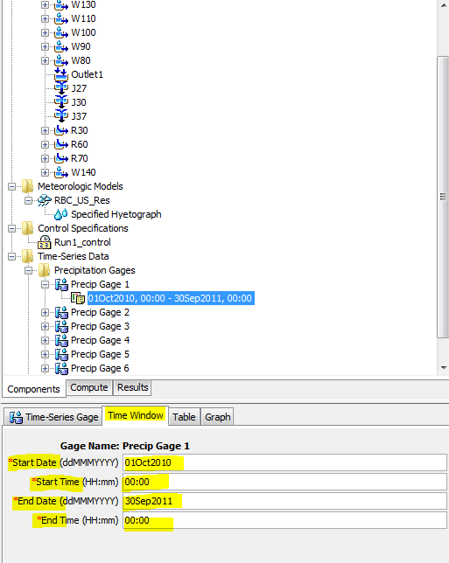

* Under the table title, precipitation of Salt Lake Traid, GHCN for Oct 2010 - Sep 2011 in mm (Precip Gage 1) has been entered

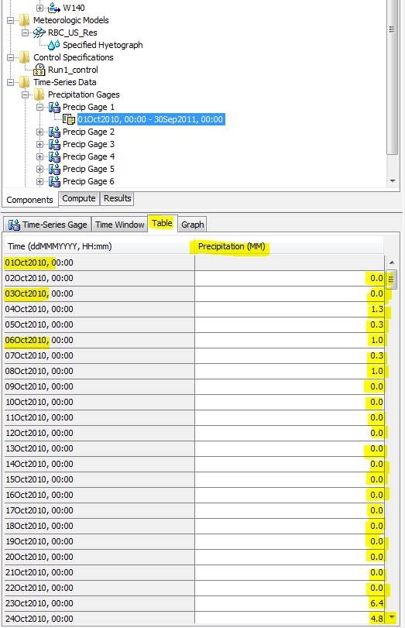

* For all sub-basin precip gage 1 data has been entered.

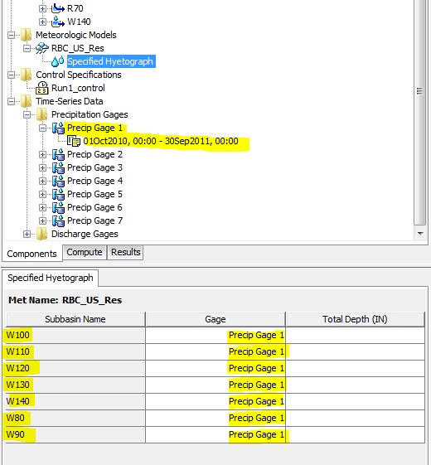

* Similarly USGS, Fort Douglas (10172200) station observed discharge (cfs) value (gage 1) for Oct 2010 – Sep 2011 has been entered.

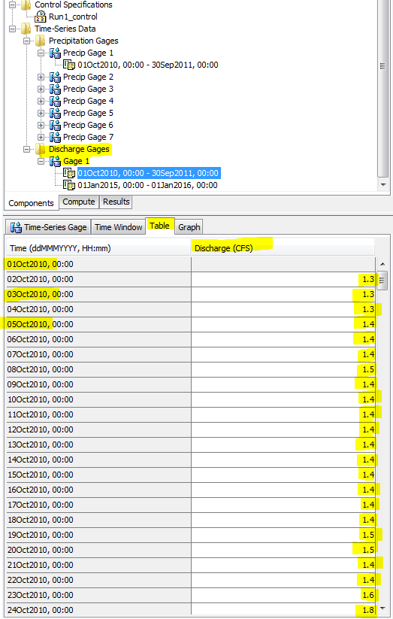

* Finally at outlet 1 USGS, observed value has been set and run the model in order to compare the simulated and observed flow.

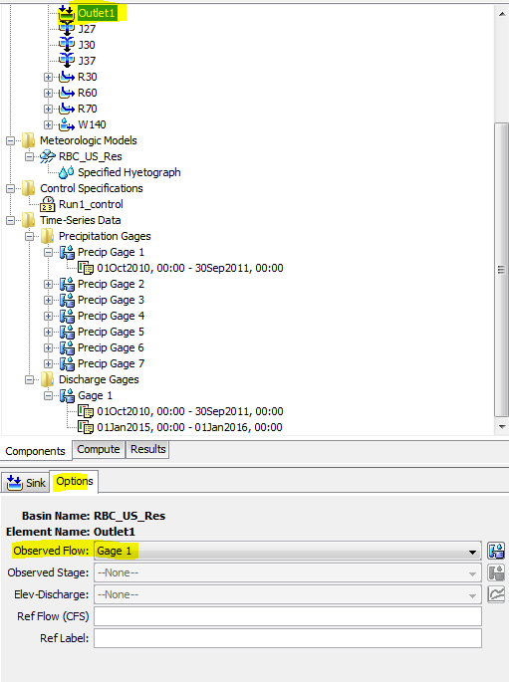

**For Green and Ampt**

1. **KF_C, Iutah site precipitation station for 2015 with baseflow**

After developing model following sub-basin, reach, precipitation, discharge and control specification parameters have been entered.

1. Sub-basin

For all seven sub basins following parameter have been entered. Here, sub-basin W80 is presented as example.

Under sub-basin title

* For each sub-basin corresponding area is entered in square miles.
* For each sub-basin Green and Ampt loss method, SCS Unit Hydrograph as Transform Method, and Constant monthly Base flow method have been selected.

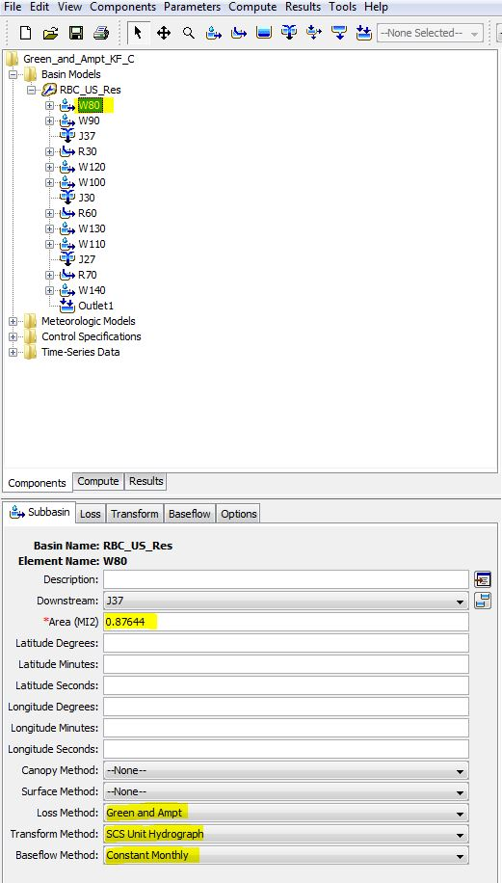

Under Loss title

* For each sub-basin corresponding initial content, saturation content, suction, Conductivity and impervious values have been entered.

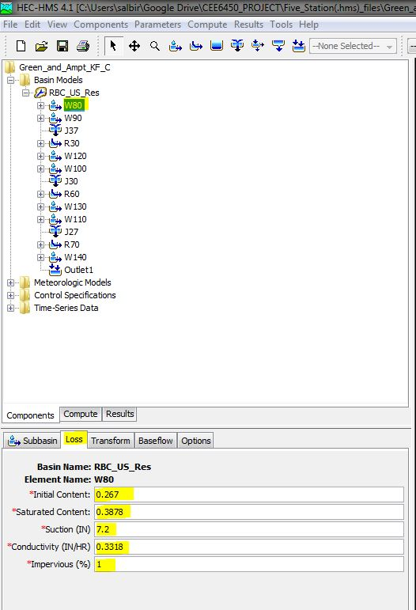

Under Transform title.

* For each sub-basin corresponding Lag time (min) have been entered

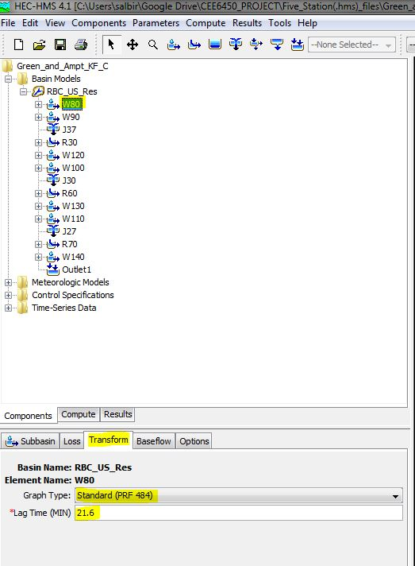

Under Base Flow title

* For each sub-basin corresponding calculated values of base flow according to USGS, Fort Douglas (10172200) station for a year 2015 have been entered.

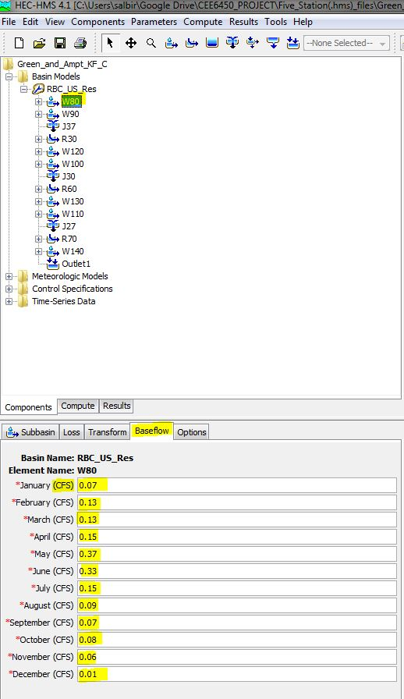

After entering all the parameters shown above under the sub-basin, loss, transform and base flow for seven sub-basin (W80, W90, W100, W110, W120, W130 and W140), Parameter required for reach have been entered.

1. Reach

For all there reaches (R30, R60 and R70) Muskingham routing method have been selected with value of muskingham coefficient K and X as 0.6 hour and 0.2. Here, reach R30 have been presented as example.

Under reach title

* + For all reach muskigham routing method have been selected

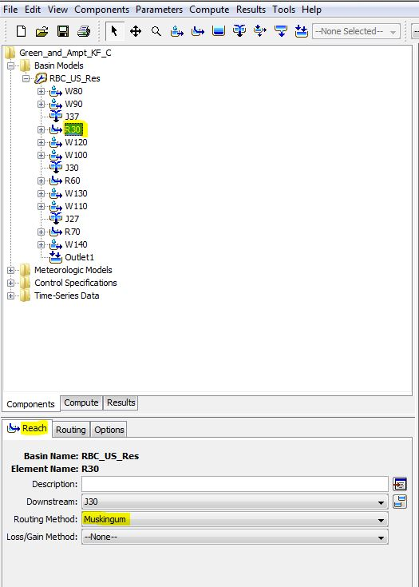

Under routing method

* + For all reaches the value of K and X entered as 0.6 hour and 0.2

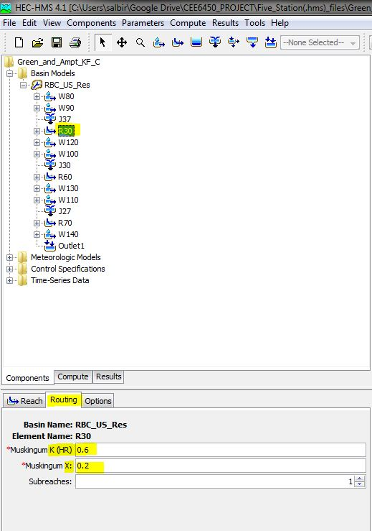

1. Precipitation

After all, the precipitation gage 1 have been created under time-series data and then following input data have been entered.

Under Time-series Gate title

* + Precipitation data have been entered in “millimeter” under the unit
  + Precipitation data have been entered at time-step of “1 day” under time interval.

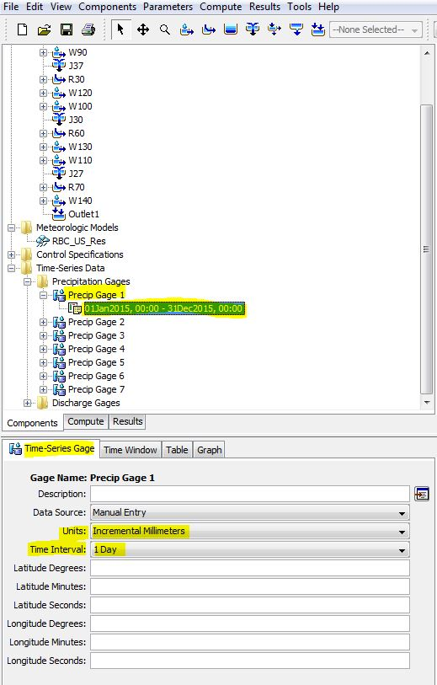

Under Time-Window table

* Start date, start time, end date and end time has been entered for 2015 precipitation data of KF_C iUtah site.

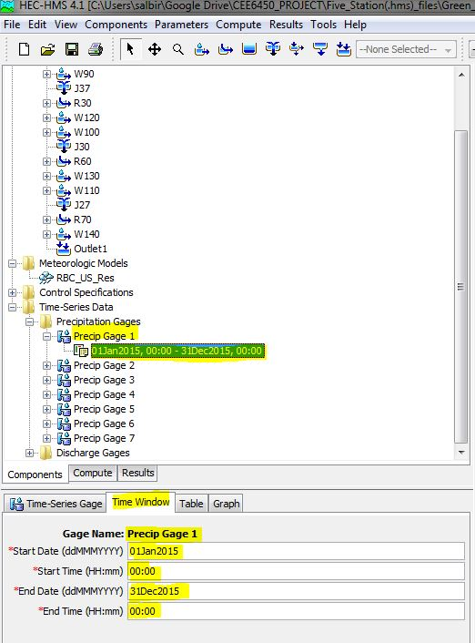

Under table title

* Precipitation data of 365 days of a year 2015 in millimeter under Precip Gage 1 has been entered manually.

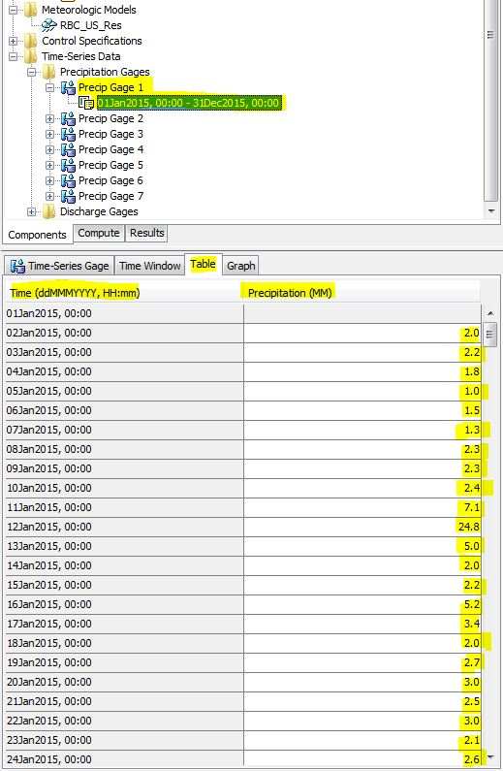

* The Hyetograph of a year 2015 under KF_C iutah site can be seen below.

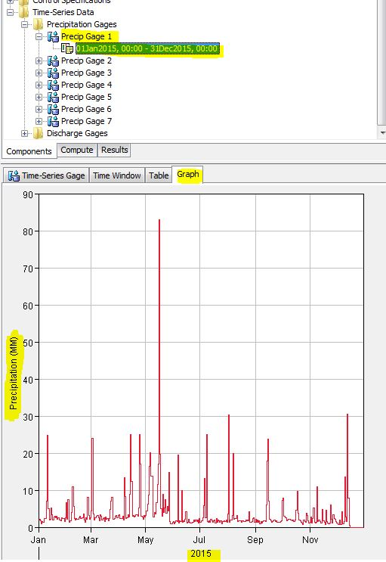

* The Metrologic model have been created and sub-basin are included by selecting “Yes” under the title Basins.

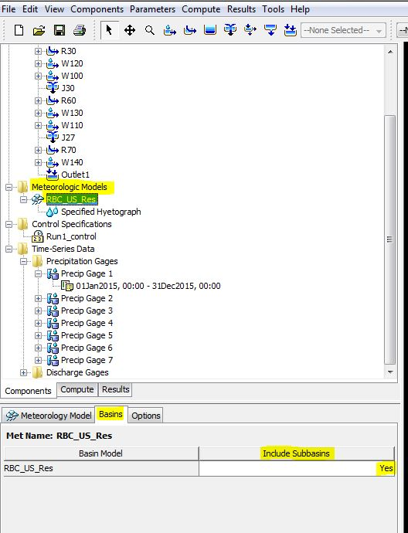

* Similarly Precipitation gage 1 has been set to all sub basins under the meteorological model and specified hyetograph

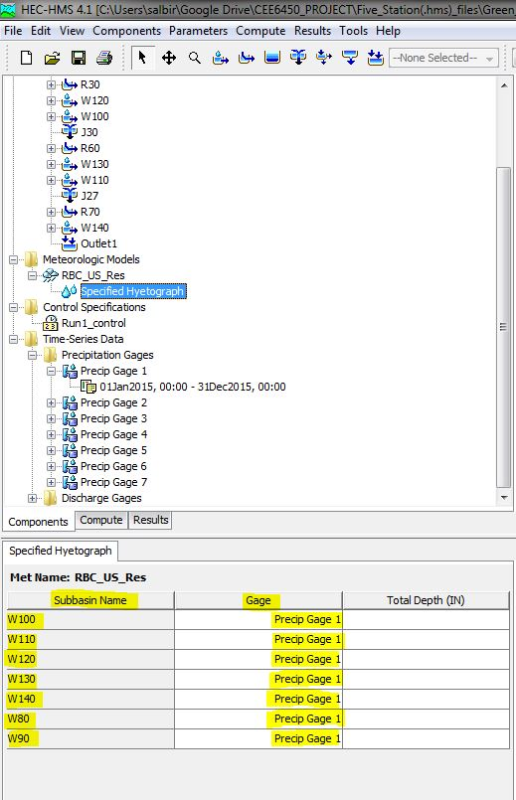

1. Discharge

Under the Time-series, discharge Gage 1 has been created and discharge data (cfs) of USGS, Fort Douglas (10172200) with time-step 1 day has been entered in following ways.

Under the Time-series gate title

* Unit of discharge data has been set in “Cubic Feet per Second” under the unit section.
* The time-step has been set as “1 day” under the time interval section.

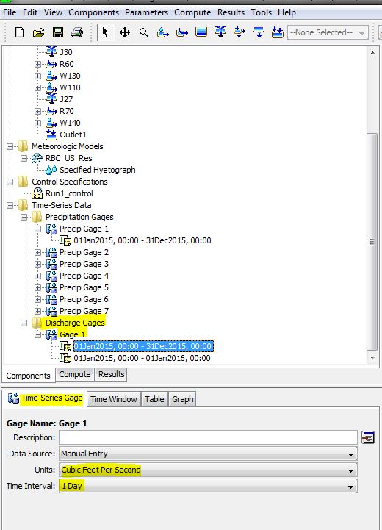

Under the Time window title

* Time period of observed discharge value of station (10172200) have been set from 01Jan2015 to 31Dec2015.

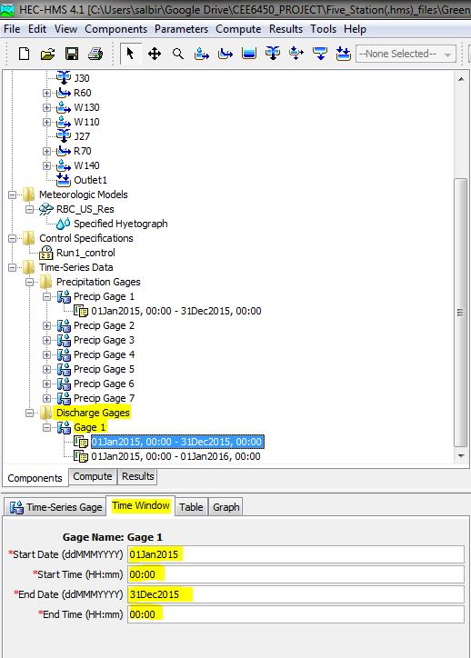

Under the table title

* Observed discharge value at USGS, Fort Douglas station (10172200) for a year of 2015 at daily time step has been entered manually.

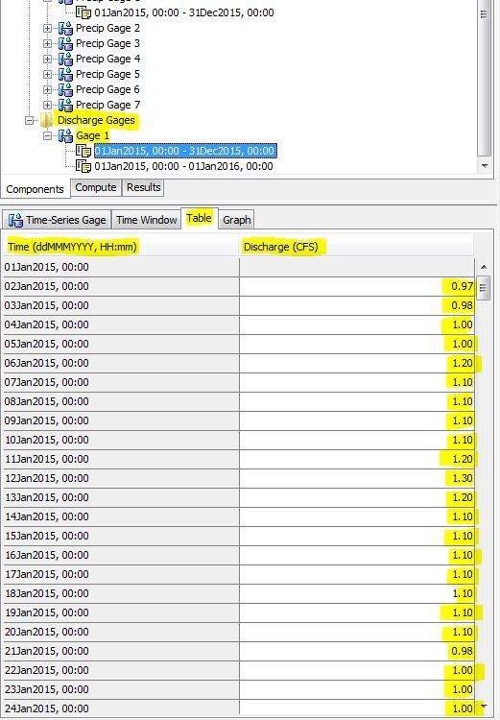

* The Hydrograph for a year of 2015 at USGS station (10172200) can be seen below.

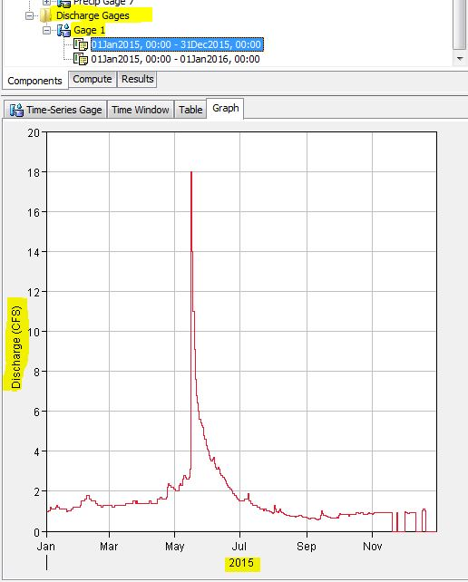

* After all, observed discharge value (gage 1) set to outlet-1 in order to compare the simulated and observed discharged value at outlet-1 as shown in below.

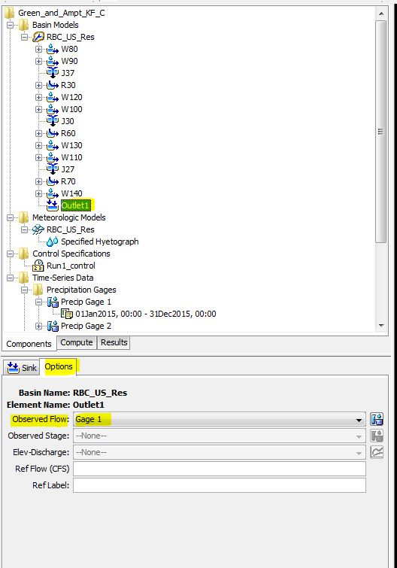

* Similarly, simulation period has been controlled with period from 01Jan2015 to 01Dec2016 and 1 day time-step.

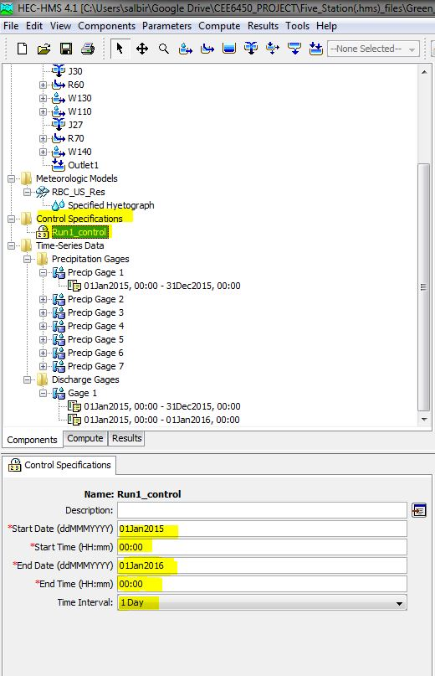

* Finally the model was run to compare the simulated and observed value at outlet-1.

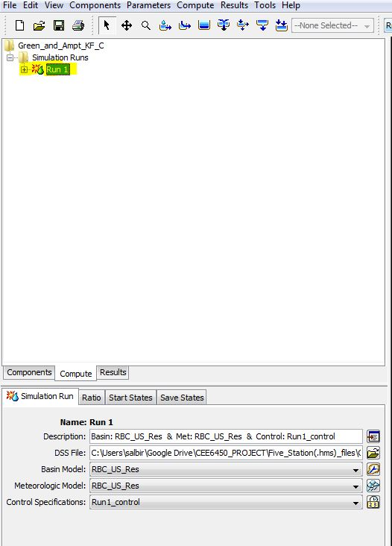

**2). Green and Ampt Loss Method:**

1. **ARBR_C, TM_C and KF_C Iutah site (three-precipitation) station for 2015 with base-flow.**

In this simulation, each and every steps are same as for KF_C , Iutah site except three precipitation stations has been considered based on elevation and location of sub-basins and stations as follow.

* + For sub-basin W80, W90, W100 and W120 : KF_C, Iutah precipitation station data has been entered
  + For sub-basins W110 and W130: TM_C, Iutah precipitation data has been entered.
  + For sub-basin W140 : ARBR_C, Iutah precipitation station data has been entered.

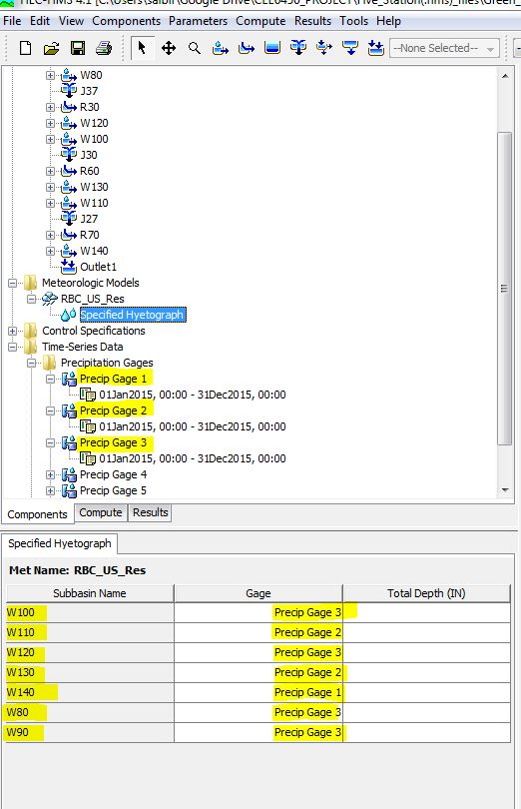

* Precipitation gage 1 (ARBR_C, Iutah) data for sub basin W140 in “mm”

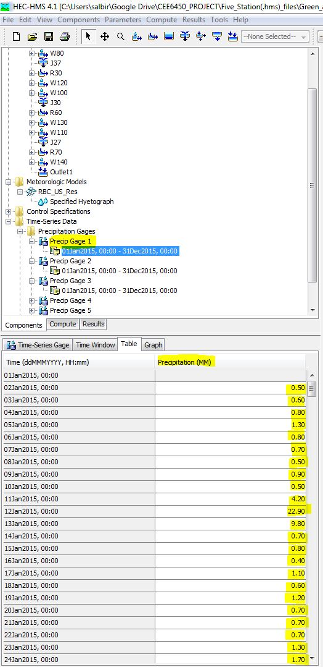

* Precipitation gage 2 (TM_C, Iutah) data for sub basin W110 and W130 in “mm”

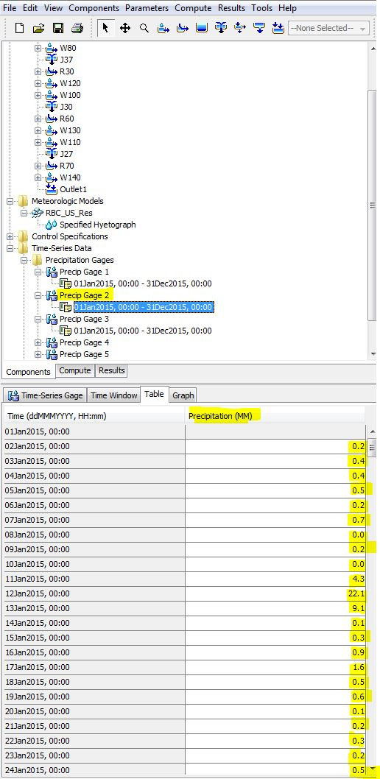

* Precipitation gage 2 (KF_C, Iutah) data for sub basin W80, W90, W100 and W120 in “mm”

